Description of our features:

1. **Rate Your Friends:**

The feature allows the user to rate each of his friends based on their support of him on Facebook.

The algorithm counts the number of likes and comments that the friend made on the user’s posts and also the number of shared groups, pages and check-ins that they have. Afterwards, it calculates the same for all the other friends of the user, and based on their score, it calculates the rank of the chosen friend.

1. **Top 3 most liked photos:**

The feature provides the user an option to view the 3 most liked photos among all the photos he ever uploaded on Facebook.

Use Case Diagram

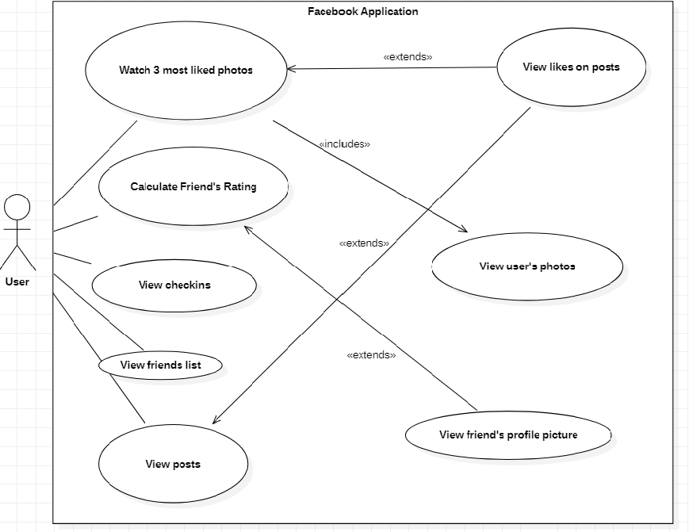

Sequence Diagram – Rate friend

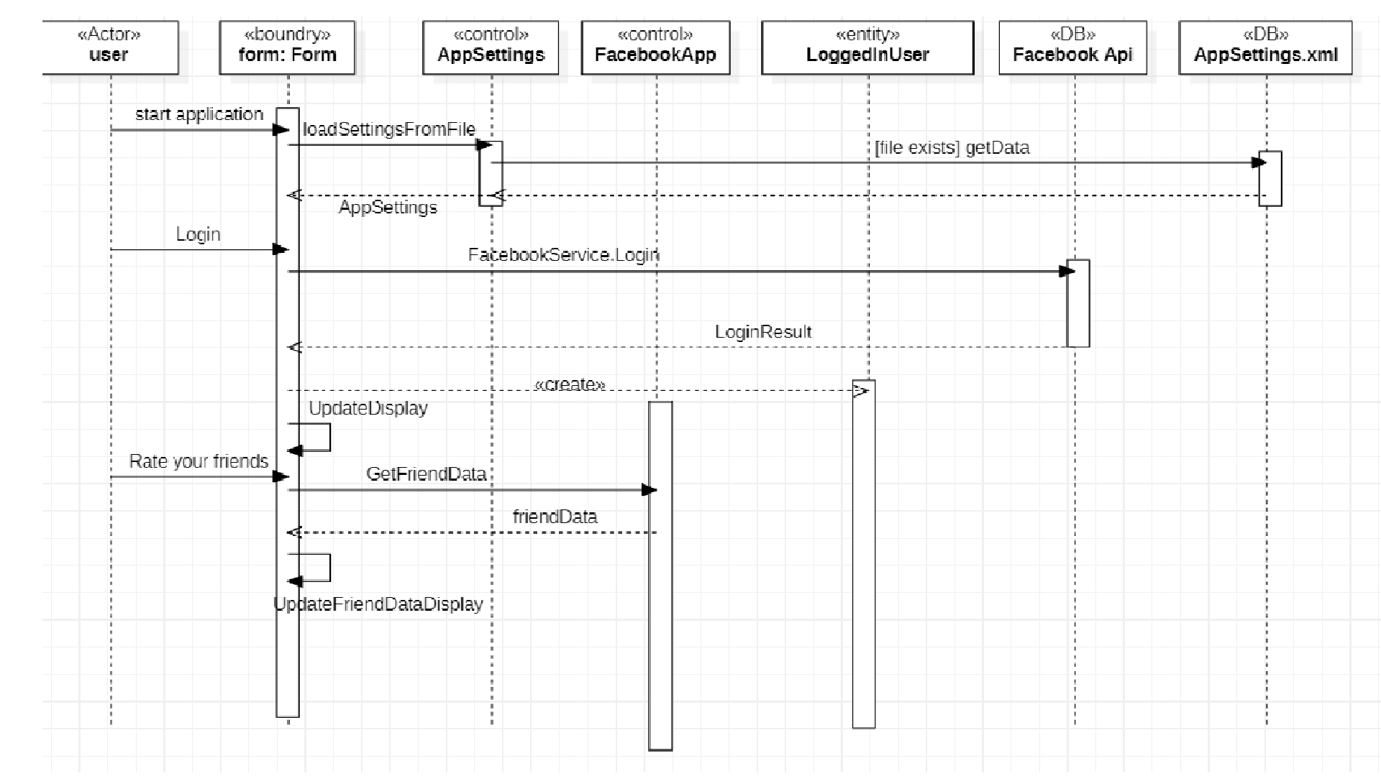

Sequence Diagram – watch 3 most liked photos

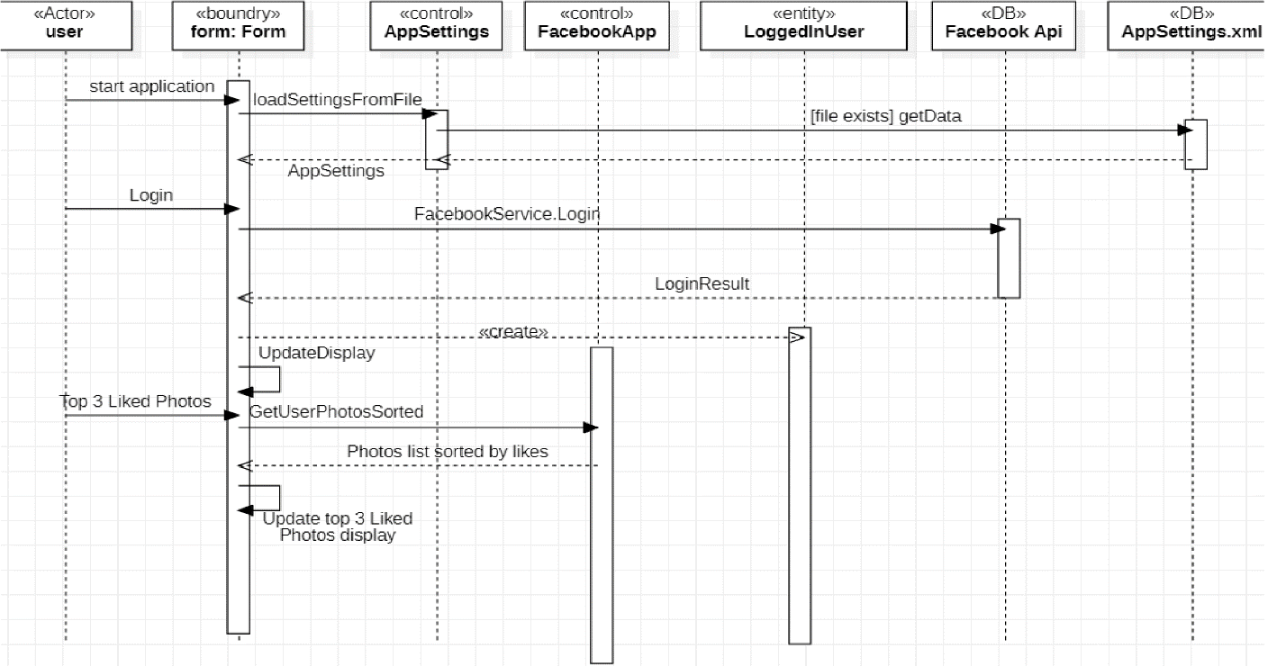

Class Diagram

